After watching the Henri Matisse workshop video, we would like you to create your own cut-out ocean scene collage in the style of Henri Matisse.
To create your collage, you will need:
Children’s
Workshop Sheet
- Glue
- Scissors
- Coloured or patterned paper/ card
- A big sheet of paper or card (to stick your collage onto)
- Have printed the templates if you would like some help to create the ocean creature shapes
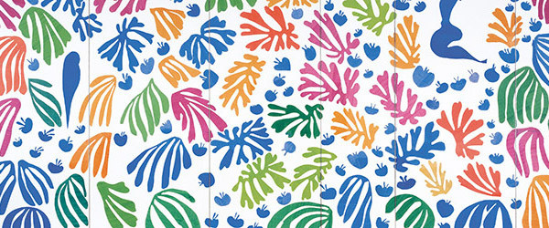
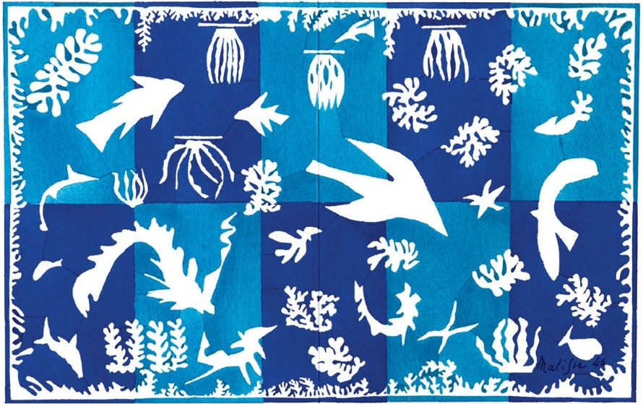
Remember to use lots of bright and bold colours and make some really interesting abstract shapes, just like Henri Matisse! Enjoy!

