Activity Sheet

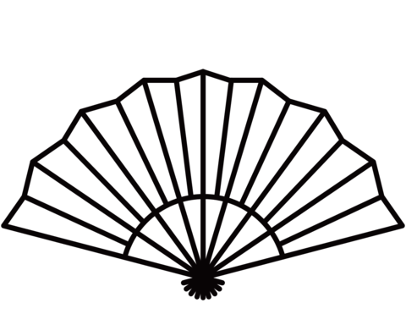

After looking at the ‘Noise of Silence: Japanese Art Now’ exhibition, design your own Japanese fans.